**Exp. 1 Design an LED flasher**

Circuit diagram

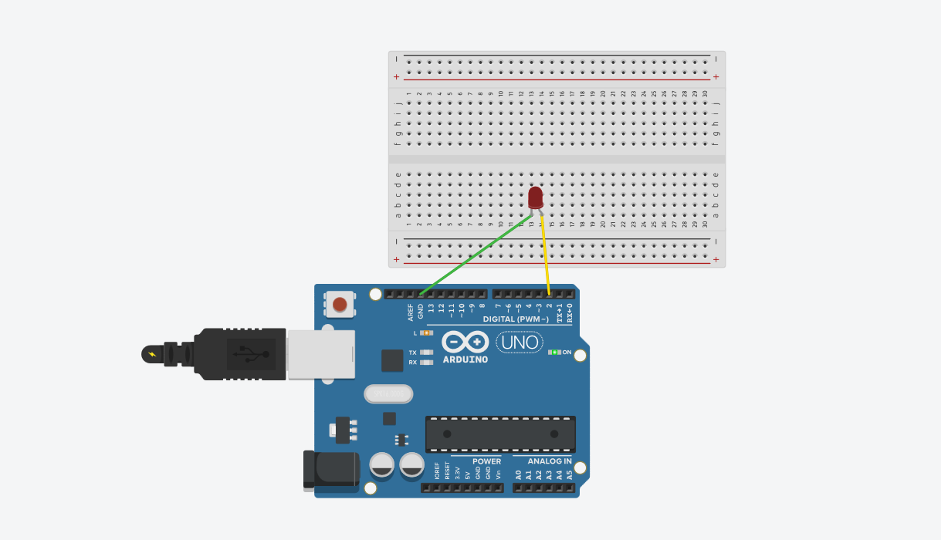

**Theory**

Concepts Used:

1. Working of Arduino UNO

2. Coding in Arduino IDE and syntax of the same

3. Working of LEDs (Light emitting diodes)

4. Making connections on a Breadboard.

Learning & Observations:

Coding in Arduino IDE: It is a very simple and systematical way to show how the circuit works. Coding is very similar to the coding in C language which we have been taught. I have learnt the importance of delay function as the micro-controller is very capable.

Arduino seems to be my first step towards HARDWARE.

Problems & Troubleshooting

I didn’t encounter any issues as it was simple to understand and perform.

Precautions

1. Remember to declare all the ports in use in digital input/output in the right way.

2. Check whether all your wire pieces are working correctly and all connections are good.

3. Remember to connect Negative end of device to GND in Arduino Uno to ensure potential difference.

Learning Outcomes

Skills that I have acquired are sound knowledge of using Arduino UNO and slight Idea of how to utilize Arduino Uno in other scenarios.